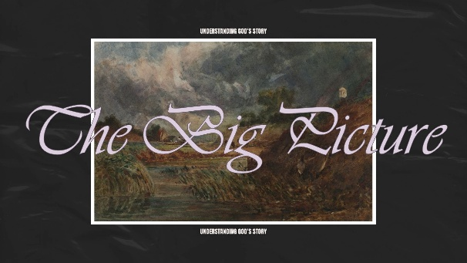

INTRODUCTION

This week’s message tries to do two things: introduce the whole series and cover the first message in it. That might be a little ambitious, but that’s what we’ve got for this Sunday. To help discuss, we’ve split the guide into two parts.

PART ONE – THE BIG PICTURE

The series is about how to better understand the Bible, and it will approach Scripture with a “Christocentric-Missional” reading. Big fancy words to say the Bible is about the unfolding narrative of God’s redemption through Christ. We will explore that theme through six major movements – The Garden, The Fall, The Chosen People (Isreal), The Chosen One (Jesus), The Church, and The New Heavens & New Earth.

What has been your experience with reading with Bible? Do you find it confusing, daunting, challenging, inspiring, or something else?

Read ACTS 8:31 – Who has helped you understand the Scriptures in your life? How did they shape your faith?

Read ACTS 8:35 – What does it mean to you that all Scripture points to or flows from Jesus? Is this the way you were taught to read the Bible and how might that approach change your understanding of it? Bonus text – check out Luke 24:27

The sermon outlined the Bible in six movements – which one are you most familiar with and which one are you least familiar with? Why?

PART TWO – THE GARDEN (GENESIS 1-2)

Genesis 1-2 is the story of creation, and it contains several foundational theological truths. Many of these truths inform the teachings in both the Old Testament and the New Testament. In other words, the creation story is foundational to understanding who God is and his original vision for mankind.

Read GENESIS 1:1 – How does believing that God created everything shape the way you view the world and your place in it? What kind of responsibilities do we have to each other and the world around us?

Read GENESIS 1:26-27 – What do you think it means to reflect the “Imago Dei” in everybody life or the way we treat others? Which teachings of Jesus seem to be rooted in this idea?

Read GENESIS 1:31 – Do you tend to see yourself (and the world in general) as fundamentally good or fundamentally bad? How does this passage shape that view?

What did Russ miss? He mentioned four foundational truths. What others do you see in the first and second chapters of Genesis? (for example – purpose, rest, relationship with God, etc.)

APPLY IT

In the end, Russ encouraged us not to jump too quickly to the fall of man, but to sit in the goodness of God’s creation. Spend some time reflecting on what it would be like to live in the Garden of Eden before sin and death.

What stands out to you about God’s original vision for humanity?

What do you long for that reflects that original vision? (for example – think about thinks like justice, health, healing, etc.)

PRAY TOGETHER

